Nama : Muhammad Ghozi Qudama

NIM : 09011282126083

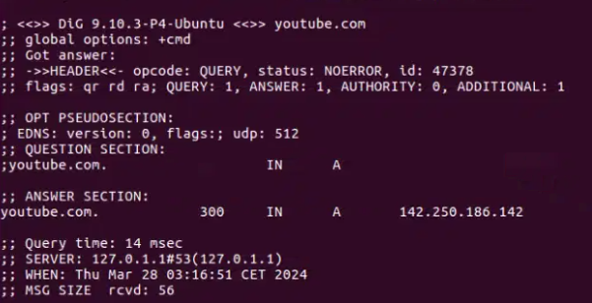

Nmap scan report for youtube.com (142.250.80.46)

Host is up (0.0022s latency).

Other addresses for youtube.com (not scanned): 2607:f8b0:4006:80b::200e

rDNS record for 142.250.80.46: lga34s34-in-f14.1e100.net

PORT STATE SERVICE

21/tcp filtered ftp

22/tcp filtered ssh

23/tcp filtered telnet

80/tcp open http

110/tcp filtered pop3

143/tcp filtered imap

443/tcp open https

3389/tcp filtered ms-wbt-server

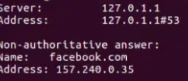

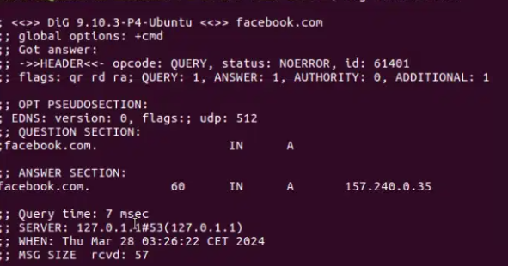

Nmap scan report for facebook.com (31.13.71.36)

Host is up (0.0017s latency).

Other addresses for facebook.com (not scanned): 2a03:2880:f112:83:face:b00c:0:25de

rDNS record for 31.13.71.36: edge-star-mini-shv-01-lga3.facebook.com

PORT STATE SERVICE

21/tcp filtered ftp

22/tcp filtered ssh

23/tcp filtered telnet

80/tcp open http

110/tcp filtered pop3

143/tcp filtered imap

443/tcp open https

3389/tcp filtered ms-wbt-server

Nmap scan report for spotify.com (35.186.224.25)

Host is up (0.0016s latency).

Other addresses for spotify.com (not scanned): 2600:1901:1:c36::

rDNS record for 35.186.224.25: 25.224.186.35.bc.googleusercontent.com

PORT STATE SERVICE

21/tcp filtered ftp

22/tcp filtered ssh

23/tcp filtered telnet

80/tcp open http

110/tcp filtered pop3

143/tcp filtered imap

443/tcp open https

3389/tcp filtered ms-wbt-server

Nmap scan report for twitch.tv (151.101.66.167)

Host is up (0.017s latency).

Other addresses for twitch.tv (not scanned): 151.101.130.167 151.101.2.167 151.101.194.167

PORT STATE SERVICE

21/tcp filtered ftp

22/tcp filtered ssh

23/tcp filtered telnet

80/tcp open http

110/tcp filtered pop3

143/tcp filtered imap

443/tcp open https

3389/tcp filtered ms-wbt-server

Nmap scan report for netflix.com (3.225.92.8)

Host is up (0.0083s latency).

Other addresses for netflix.com (not scanned): 54.160.93.182 3.211.157.115 2600:1f18:631e:2f84:4f7a:4092:e2e9:c617 2600:1f18:631e:2f83:49ee:beaa:2dfd:ae8f 2600:1f18:631e:2f85:93a9:f7b0:d18:89a7

rDNS record for 3.225.92.8: ec2-3-225-92-8.compute-1.amazonaws.com

PORT STATE SERVICE

21/tcp filtered ftp

22/tcp filtered ssh

23/tcp filtered telnet

80/tcp open http

110/tcp filtered pop3

143/tcp filtered imap

443/tcp open https

3389/tcp filtered ms-wbt-server